Name | Kyung-Mi Lee | 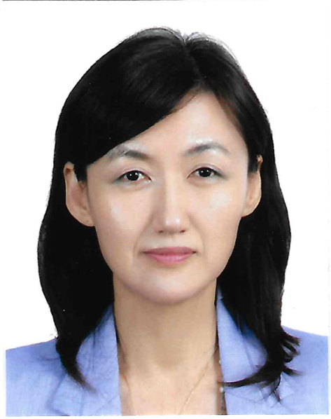
Affiliation | Department of Biochemistry,  Korea University Medical School
Official Position | Professor
Education | 1983 – 87 Seoul National University B.S. - Pharmacy  1987 – 89 Seoul National University M.S. - Physical Pharmacy  1989 – 95 University of Chicago, Chicago, IL Ph.D. – Pharmacology and Physiology
Major Career  (less than  5 items) | 1995 – 96 Dept. of Pathology, Harvard Medical School Post-Doctoral Fellow  1997 – 04 Dept. of Pathology, University of Chicago Research Assistant Professor  2009 – pre Dept. of Biochemistry, Korea University Medical School Professor  2013 – 18 Dept. of Melanoma Medical Oncology, MD Anderson Joint Associate professor  2019 – pre Dept. of Bio-Integrated Electronics, University of Northwestern Research adjunct professor
Biography
Kyung-Mi Lee obtained B.S. and M.S. degrees from the College of Pharmacy at Seoul National University and Ph. D. in the department of Pharmacology and Physiology at the University of Chicago. She completed postdoctoral training at Harvard Medical School, then was appointed as a research associate professor at UOC. Since joining as a faculty at Korea University in 2003, her research has focused on understanding the mechanism of immune cell signal transduction in the setting of cancer as well as autoimmune diseases. She developed many translational approaches based on the mechanisms found in the specific disease settings. Now her research extends to the epigenetic changes of T cells and NK cells that can potentially provide a basis for the therapeutic targets. She is also developing NK and T cells immunotherapy for less invasive therapeutic strategies for cancer. In addition, her laboratory has been involved in cross-disciplinary efforts in biomedical engineering and the development of unique biomaterial platform for immune cell detection, selection, and expansion as a means of enhancing the human immune response both in vitro and in vivo.

